**1. INTRODUCTION**

The GatherGO platform is a comprehensive event management solution designed to streamline the planning and execution of various events, including weddings, corporate gatherings, birthday parties, and more. It provides users with tools to browse venues, select catering options, manage bookings, and customize event details. The platform integrates modern technologies like responsive design, interactive UI elements, and robust backend systems to deliver a seamless user experience.

* 1. **Problem Definiton**

Event planning often involves multiple challenges, such as coordinating logistics, managing vendor relationships, and ensuring customer satisfaction. Traditional methods of event planning rely heavily on manual processes, leading to inefficiencies, miscommunication, and a lack of personalization. Key problems addressed by the GatherGO platform include:

* Difficulty in finding suitable venues and services tailored to specific event needs.
* Lack of centralized platforms for managing catering, decor, and logistics.
* Inefficient communication between event planners and clients.
* Limited personalization options for customers.

**1.2Existing System**

The existing systems for event management are fragmented and often rely on offline processes or standalone applications. These systems typically have the following limitations:

Manual Coordination : Event planners must manually coordinate with vendors, venues, and clients, leading to delays and errors.

Limited Accessibility : Most traditional systems lack mobile-friendly interfaces, making it difficult for users to access services on the go.

Generic Solutions : Existing platforms often fail to provide personalized recommendations based on user preferences.

Inadequate Inventory Management : Catering and decor services are not integrated into a single system, resulting in inventory mismatches and overbooking.

**1.3 Proposed System**

The proposed GatherGO platform aims to address the shortcomings of existing systems by offering a unified, user-friendly solution for event management. Key features of the proposed system include:

Centralized Platform : A single interface for browsing venues, selecting catering options, and managing bookings.

Personalization : AI-driven recommendations for venues, catering, and decor based on user preferences.

Responsive Design : A mobile-first approach ensures accessibility across devices (desktop, tablet, and mobile).

Integrated Backend : A robust backend system manages user data, inventory, and logistics efficiently.

Real-Time Updates : Users receive real-time notifications about booking confirmations, order status, and event details.

Enhanced Security : Data encryption and secure authentication mechanisms protect user information.

**1.4 Literature Review**

**1.4.1. User Experience and Personalization**

The GatherGO platform prioritizes user experience and personalization to enhance customer satisfaction. Key aspects include:

* **Responsive Design :** The platform uses Tailwind CSS to create a responsive layout that adapts to different screen sizes, ensuring a seamless experience for both desktop and mobile users.
* **Customizable Options :** Users can tailor their event planning experience by selecting specific services, such as buffet or table dining, and customizing decor themes.
* **AI-Driven Recommendations :** While not explicitly implemented in the current code, the platform's structure supports future integration of AI algorithms to recommend venues and services based on user behavior.

**1.4.2. Inventory Management and Customer Support**

Efficient inventory management and reliable customer support are critical components of the GatherGO platform.

* **Inventory Management :**The platform maintains a structured database for managing venues, catering items, and decor services.
* **Customer Support :**The platform includes a dedicated "Help & Support" section to assist users with FAQs and contact options.

Privacy settings allow users to control how their data is shared, enhancing trust and transparency.

**2. SYSTEM REQUIREMENTS**

**2.1 HARDWARE AND SOFTWARE REQUIREMENTS:**

Software Requirements

* Operating System: Windows 10/11 or Linux (Ubuntu, CentOS)
* Web Server: Apache HTTP Server or Nginx
* Frontend:
  + HTML5
  + CSS3 (Tailwind CSS Framework)
  + JavaScript
* Middleware:Node.js (for handling server-side logic and APIs)
* Backend: Python (Flask/Django)
* Database: MySQL
* Browsers:
  + Google Chrome
  + Mozilla Firefox
  + Microsoft Edge

Hardware Requirements

* Server:
  + Processor: Multi-core (e.g., Intel i5)
  + RAM: 16 GB (32 GB recommended)
  + Storage: 512 GB SSD
  + Network: High-speed internet connection
  + Backup System :cloud-based backup solution
* Client:
  + Processor: Dual-core processor (e.g., Intel i3)
  + RAM: 4 GB (8 GB recommended)
  + Storage: 100 GB free space
  + Network: Stable internet connection

**2.2 Software Requirements Specification (SRS)**

**2.2.1.Functional Requirements**

**User Registration and Login :**

* Users can create accounts, log in, and manage their profiles.
* Password encryption and secure authentication mechanisms are implemented.

**Event Browsing :**

* Users can search and browse venues by category (e.g., weddings, parties, corporate events).
* Venues are displayed with details such as location, capacity, and pricing.

**Catering Services :**

* Users can select catering options (buffet or table dining).
* Food items can be added to a cart, viewed, and removed.

**Booking System :**

* Users can book venues and catering services.
* Booking confirmation and order summary are provided upon submission.

**Cart Management :**

* Users can add, view, and remove catering items in their cart.
* Total price is dynamically updated.

**Contact Us :**

* Users can send inquiries via a contact form.

**Gallery :**

* Users can view images of past events, venues, and catering setups.

**Settings :**

* Users can manage account settings, privacy preferences, and notifications.

**2.2.2.Non-Functional Requirements**

1. Performance: Support for 1000 concurrent users; page load time under 3 seconds.
2. Security: Data encryption and secure password storage.
3. Usability: Intuitive UI accessible on both desktop and mobile.
4. Reliability: 99.9% uptime with regular backups.

**2.2.3.Hardware Requirements**

1. Processor: Multi-core processor (e.g., Intel Xeon or AMD Ryzen) for efficient handling of concurrent user requests.
2. RAM: Minimum 16 GB (32 GB recommended) to support multiple processes and users simultaneously.
3. Storage: 512 GB SSD for fast data access and improved performance.
4. Network: High-speed internet connection (minimum 100 Mbps) to handle user traffic effectively.

**3.SYSTEM DESIGN**

User Interface (UI) Design

* Focus: Create an intuitive and user-friendly interface for customers and event planners.
* Key Elements:
  + Responsive design for web and mobile
  + Easy navigation and search functionality
  + Clear product venue details, catering options, and booking process
  + Interactive elements like hover effects and clickable cards for better engagement.

 Backend Architecture

* Focus: Develop a robust backend to handle business logic and data management.
* Key Elements:
  + RESTful APIs for communication between frontend and backend
  + Database management for user, venue, catering, and booking data
  + Security measures for data protection and user authentication

Database Design

* Focus: Structure the database to efficiently store and retrieve data.
* Key Elements:
* Users (user_id, name, email, password_hash, phone_number, etc.)
* Venues (venue_id, name, location, capacity, price, etc.)
* Catering (catering_id, food_item, price, category, etc.)
* Orders (order_id, user_id, venue_id, catering_items, total_price, etc.)
* Relationships between tables (e.g., users to orders, venues to bookings).
* Indexing for fast data retrieval (e.g., indexing on venue location, user email).

**3.2 UML DIAGRAM:**

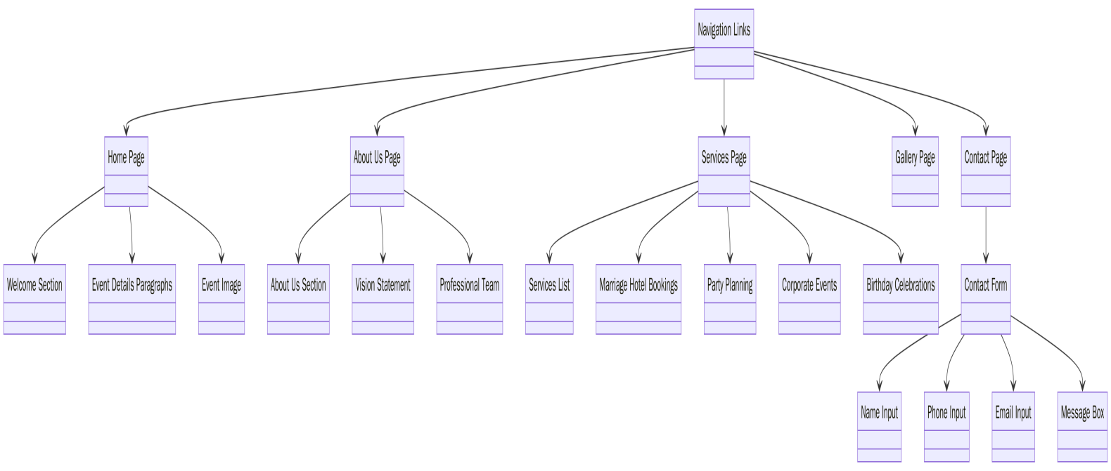

**4. IMPLEMENTATION**

**4.1 Sample Code:**

<!DOCTYPE html>

<html lang="en">

<head>

<meta charset="UTF-8">

<meta name="viewport" content="width=device-width, initial-scale=1.0">

<title>GatherGO - Creating Unforgettable Events</title>

<script src="https://cdn.tailwindcss.com"></script>

<link href="https://fonts.googleapis.com/css2?family=Roboto:wght@400;700&display=swap" rel="stylesheet">

<link rel="stylesheet" href="https://cdnjs.cloudflare.com/ajax/libs/font-awesome/5.15.3/css/all.min.css">

<style>

header {

background-color: white;

padding: 1rem;

}

.logo-container {

display: flex;

align-items: center;

}

.logo-container img {

width: 80px;

height: 80px;

margin-right: 1rem;

}

.text-container h1 {

font-family: 'Cursive Font', cursive; /* Replace with your preferred cursive font */

color: #ff69b4; /* Pink color for the logo text */

}

.text-container p {

font-size: 0.8rem;

color: #888;

}

body {

font-family: 'Roboto', sans-serif;

}

{

margin-left: 10px;

}

.profile-dropdown {

display: none;

position: absolute;

right: 0;

background-color: white;

min-width: 160px;

box-shadow: 0px 8px 16px 0px rgba(0,0,0,0.2);

z-index: 1;

border-radius: 0.5rem;

}

.profile-dropdown a {

color: #4a5568;

padding: 12px 16px;

text-decoration: none;

display: block;

}

.profile-dropdown a:hover {

background-color: #f7fafc;

color: #d53f8c;

}

.profile-container:hover .profile-dropdown {

display: block;

}

.cart-dropdown {

display: none;

position: absolute;

right: 0;

background-color: white;

min-width: 300px;

box-shadow: 0px 8px 16px 0px rgba(0,0,0,0.2);

z-index: 1;

border-radius: 0.5rem;

padding: 1rem;

}

.cart-container:hover .cart-dropdown {

display: block;

}

.cart-item {

display: flex;

justify-content: space-between;

padding: 0.5rem 0;

border-bottom: 1px solid #e2e8f0;

}

</style>

</head>

<body class="bg-gray-100">

<nav id="navbar" class="flex items-center p-4 bg-white shadow-md">

<button id="backButton" class="hidden text-pink-600 hover:text-pink-800" onclick="goBack()">

<i class="fas fa-arrow-left"></i>

</button>

<span class="text-pink-600 font-bold text-xl mr-4">GatherGO</span>

<div class="flex-grow"></div>

<div class="flex space-x-6 items-center">

<a href="#" onclick="loadPage('home')" class="nav-link flex items-center flex-shrink-0 px-5 py-2 border-b-4 border-transparent text-pink-600 hover:border-pink-600">HOME</a>

<a href="#" onclick="loadPage('about')" class="nav-link flex items-center flex-shrink-0 px-5 py-2 border-b-4 border-transparent text-pink-600 hover:border-pink-600">ABOUT</a>

<a href="#" onclick="loadPage('services')" class="nav-link flex items-center flex-shrink-0 px-5 py-2 border-b-4 border-transparent text-pink-600 hover:border-pink-600">SERVICES</a>

<a href="#" onclick="loadPage('gallery')" class="nav-link flex items-center flex-shrink-0 px-5 py-2 border-b-4 border-transparent text-pink-600 hover:border-pink-600">GALLERY</a>

<a href="#" onclick="loadPage('contact')" class="nav-link flex items-center flex-shrink-0 px-5 py-2 border-b-4 border-transparent text-pink-600 hover:border-pink-600">CONTACT</a>

<div class="flex items-center space-x-4 ml-6">

<button onclick="toggleSearchBox()" class="text-pink-600 hover:text-pink-800">

<i class="fas fa-search"></i>

</button>

<div id="searchBox" class="hidden">

<input type="text" id="searchInput" placeholder="Search..." class="border rounded-lg px-2 py-1">

</div>

</div>

<div class="cart-container relative">

<button class="text-pink-600 hover:text-pink-800 ml-4">

<i class="fas fa-shopping-cart"></i>

<span id="cartCount" class="absolute -top-2 -right-2 bg-pink-600 text-white text-xs rounded-full h-5 w-5 flex items-center justify-center">0</span>

</button>

<div class="cart-dropdown">

<h4 class="font-bold text-gray-800 mb-2">Your Catering Order</h4>

<div id="cartItems">

<p class="text-gray-500">Your cart is empty</p>

</div>

<div class="mt-4">

<button onclick="clearCart()" class="text-sm text-pink-600 hover:text-pink-800">Clear Cart</button>

</div>

</div>

</div>

<div class="profile-container relative ml-4">

<button class="text-pink-600 hover:text-pink-800">

<i class="fas fa-user-circle text-xl"></i>

</button>

<div class="profile-dropdown">

<a href="#" onclick="loadPage('profile')"><i class="fas fa-user mr-2"></i> Profile</a>

<a href="#" onclick="loadPage('settings')"><i class="fas fa-cog mr-2"></i> Settings</a>

<a href="#" onclick="loadPage('login')"><i class="fas fa-sign-out-alt mr-2"></i> Logout</a>

</div>

</nav>

<main id="content" class="mt-20 px-6"></main>

<script>

let previousPage = 'login';

let historyStack = ['login']; // Stack to track navigation history

let cartItems = []; // Array to store cart items

function loadPage(page, hotelName = '', option = '') {

console.log(`Loading page: ${page}`); // Debugging

let content = document.getElementById('content');

let navbar = document.getElementById('navbar');

let backButton = document.getElementById('backButton');

if (!content) {

console.error('Content element not found');

return;

}

if (page === 'login' || page === 'signup') {

navbar.classList.add('hidden');

} else {

navbar.classList.remove('hidden');

}

if (page !== 'home' && page !== 'login' && page !== 'signup') {

backButton.classList.remove('hidden');

} else {

backButton.classList.add('hidden');

}

if (page !== historyStack[historyStack.length - 1]) {

historyStack.push(page);

}

switch (page) {

case 'login':

content.innerHTML = `

<header class="bg-white p-4 flex justify-between items-center">

<div class="logo-container">

<img src="https://bcassetcdn.com/social/dtagfrf820/preview.png" alt="Gathergo Logo" class="w=32">

<div class="text-container">

<h1 class="text-2xl font-bold text-pink-600">GATHERGO</h1>

<p class="text-sm text-gray-500">YOUR EVENT. YOUR WAY!</p>

</div>

</div>

</header>

<section class="py-16 flex flex-col md:flex-row bg-gray-50">

<div class="md:w-1/2 p-8 flex flex-col justify-center items-center">

<h2 class="text-4xl font-bold text-gray-900 mb-6 text-center">Welcome Back!</h2>

<form class="w-full max-w-md bg-white p-8 rounded-lg shadow-lg transition-all duration-300 hover:shadow-xl" onsubmit="handleLogin(event)">

<div class="mb-5">

<label class="block text-gray-700 font-medium mb-2">Email Address</label>

<input type="email" id="email" class="w-full p-3 border border-gray-300 rounded-lg focus:outline-none focus:border-pink-500 transition-colors" placeholder="Enter your email" required>

</div>

<div class="mb-5">

<label class="block text-gray-700 font-medium mb-2">Password</label>

<input type="password" id="password" class="w-full p-3 border border-gray-300 rounded-lg focus:outline-none focus:border-pink-500 transition-colors" placeholder="Enter your password" required>

</div>

<button type="submit" class="w-full bg-gradient-to-r from-pink-500 to-purple-500 text-white font-semibold py-3 rounded-lg hover:from-pink-600 hover:to-purple-600 transition-all duration-300">

Login

</button>

<p class="mt-5 text-sm text-gray-600 text-center">Don't have an account?

<a href="#" onclick="loadPage('signup')" class="text-pink-600 font-medium hover:text-pink-800 transition-colors">Sign Up</a>

</p>

</form>

</div>

<div class="md:w-1/2 p-8 flex justify-center items-center">

</div>

</section>`;

break;

case 'home':

content.innerHTML = `

<section class="relative overflow-hidden">

<div class="absolute inset-0 bg-black opacity-50"></div>

<div class="container mx-auto px-4 sm:px-6 lg:px-8 relative z-10 flex items-center justify-center h-full">

<div class="text-center">

<h1 class="text-6xl font-bold text-white mb-4">Welcome to GatherGO</h1>

<p class="text-xl text-white max-w-2xl mx-auto mb-8">Transforming your special moments into unforgettable experiences.</p>

</div>

</div>

</div>

<section class="py-20 bg-gray-50">

<div class="container mx-auto px-4 sm:px-6 lg:px-8">

<h2 class="text-4xl font-bold text-gray-800 text-center mb-12">Our Services</h2>

<div class="grid grid-cols-1 md:grid-cols-2 lg:grid-cols-3 gap-8">

<div class="bg-white p-6 rounded-lg shadow-md text-center">

<div class="w-16 h-16 bg-blue-500 rounded-full mx-auto flex items-center justify-center mb-4">

</svg>

</div>

<h3 class="text-2xl font-semibold text-gray-800 mb-2">Event Planning</h3>

<p class="text-gray-600">End-to-end planning for weddings, corporate events, and more.</p>

</div>

<div class="bg-white p-6 rounded-lg shadow-md text-center">

<div class="w-16 h-16 bg-green-500 rounded-full mx-auto flex items-center justify-center mb-4">

</svg>

</div>

<h3 class="text-2xl font-semibold text-gray-800 mb-2">Venue Selection</h3>

<p class="text-gray-600">Find the perfect venue tailored to your event's needs.</p>

</div>

<div class="bg-white p-6 rounded-lg shadow-md text-center">

<div class="w-16 h-16 bg-red-500 rounded-full mx-auto flex items-center justify-center mb-4">

</svg>

</div>

<h3 class="text-2xl font-semibold text-gray-800 mb-2">Logistics Management</h3>

<p class="text-gray-600">Streamline logistics for seamless event execution.</p>

</div>

</div>

</div>

</section>

<section class="py-16 bg-gray-800 text-white">

<div class="container mx-auto px-4 sm:px-6 lg:px-8">

<h2 class="text-3xl font-bold text-center mb-8">User Profile</h2>

<div class="max-w-2xl mx-auto bg-gray-700 p-8 rounded-lg shadow-lg">

<h3 class="text-2xl font-semibold mb-4">Personal Information</h3>

<ul class="space-y-2">

<li><strong>Name:</strong> CH.SAI KRISHNA</li>

<li><strong>Email:</strong>SAIKRISHNA@example.com</li>

</ul>

</div>

</div>

</section>

</section>

break;

case 'contact':

content.innerHTML = `

<section class="py-16 bg-gray-50">

<div class="container mx-auto text-center">

<h2 class="text-4xl font-bold text-gray-800">Contact Us</h2>

<p class="mt-4 text-lg text-gray-600">We're here to help! Reach out to us for any inquiries or assistance.</p>

</div>

<div class="container mx-auto mt-12 flex flex-col md:flex-row gap-8">

<div class="w-full md:w-1/2 bg-white p-8 rounded-lg shadow-lg">

<h3 class="text-2xl font-semibold text-gray-800 mb-6">Send Us a Message</h3>

<form id="contactForm" onsubmit="handleContact(event)" novalidate>

<div class="mb-5">

<label for="fullName" class="block text-sm font-medium text-gray-700 mb-1">Full Name</label>

<input>

type="text"

id="fullName"

name="fullName"

placeholder="Enter your full name"

class="w-full px-4 py-3 border border-gray-300 rounded-md focus:outline-none focus:ring-2 focus:ring-pink-600"

required

aria-label="Full Name"

<div class="mb-5">

<label for="phoneNumber" class="block text-sm font-medium text-gray-700 mb-1">Phone Number</label>

<input

type="tel"

id="phoneNumber"

name="phoneNumber"

placeholder="Enter your phone number"

class="w-full px-4 py-3 border border-gray-300 rounded-md focus:outline-none focus:ring-2 focus:ring-pink-600"

required

aria-label="Phone Number"

</div>

<div class="mb-5">

<label for="emailAddress" class="block text-sm font-medium text-gray-700 mb-1">Email Address</label>

<div class="w-full md:w-1/2 bg-white p-8 rounded-lg shadow-lg">

<h3 class="text-2xl font-semibold text-gray-800 mb-6">Get in Touch</h3>

<p class="text-gray-600 mb-6">Have questions about our services? Want to discuss your event details? Feel free to reach out to us!</p>

<div class="space-y-4">

<p class="flex items-center text-gray-700">

<i class="fas fa-map-marker-alt mr-2 text-pink-600"></i>

123, Event Plaza, India

</p>

<p class="flex items-center text-gray-700">

<i class="fas fa-phone mr-2 text-pink-600"></i>

+91 999 673 984

</p>

</div>

<div class="mt-8">

<h4 class="text-lg font-semibold text-gray-800 mb-4">Working Hours</h4>

<ul class="space-y-2 text-gray-600">

<li>Monday - Friday: 9:00 AM - 6:00 PM</li>

<li>Saturday: 10:00 AM - 4:00 PM</li>

<li>Sunday: Closed</li>

</ul>

</section>

</script>

<footer class="bg-black text-white py-10 mt-10">

<div class="container mx-auto px-6">

<div class="grid grid-cols-1 md:grid-cols-3 gap-8 text-center md:text-left">

<div>

<h3 class="text-lg font-bold">Company Overview</h3>

<p class="text-gray-400 mt-2">

With a commitment to excellence and customer satisfaction, we strive to deliver premium quality

and innovative solutions tailored to meet your needs.

</p>

</div>

<div>

<h3 class="text-lg font-bold">Contact</h3>

<p class="text-gray-400 mt-2 flex items-center justify-center md:justify-start">

<i class="fas fa-map-marker-alt mr-2"></i> 123, Event Plaza, India

</p>

<p class="text-gray-400 mt-2 flex items-center justify-center md:justify-start">

<i class="fas fa-phone mr-2"></i> 999 673 984

</p>

<p class="text-gray-400 mt-2 flex items-center justify-center md:justify-start">

<i class="fas fa-envelope mr-2"></i> support@gathergo.com

</p>

</div>

<div>

<h3 class="text-lg font-bold">Services</h3>

<ul class="text-gray-400 mt-2 space-y-1">

<li>Party Planning</li>

</ul>

</div>

<div class="border-t border-gray-700 mt-6 pt-4 flex flex-col md:flex-row justify-between items-center text-gray-400">

<p>Copyright 2024 All Rights Reserved. Made by </p>

<div class="flex space-x-4 mt-4 md:mt-0">

<a href="#" class="text-white bg-gray-700 p-2 rounded-full"><i class="fab fa-facebook-f"></i></a>

<a href="#" class="text-white bg-gray-700 p-2 rounded-full"><i class="fab fa-twitter"></i></a>

<a href="#" class="text-white bg-gray-700 p-2 rounded-full"><i class="fab fa-linkedin-in"></i></a>

</div>

</footer>

</body>

</html>

**5.RESULTS**

**5.1 Output Screens:**

\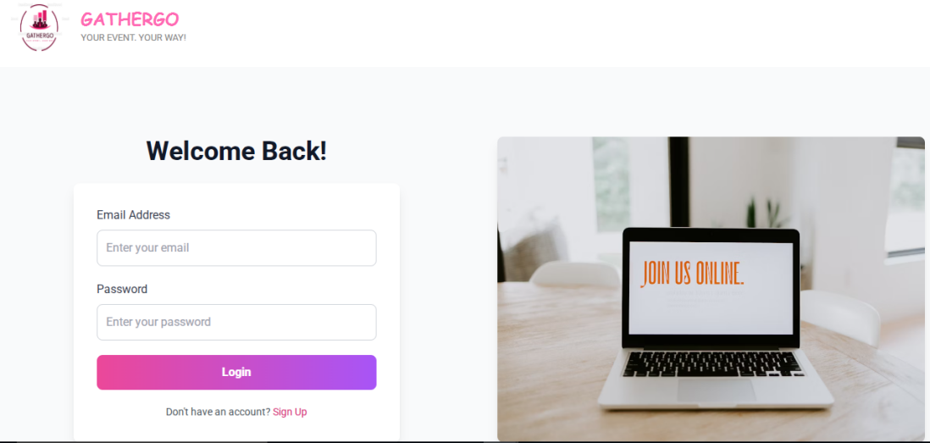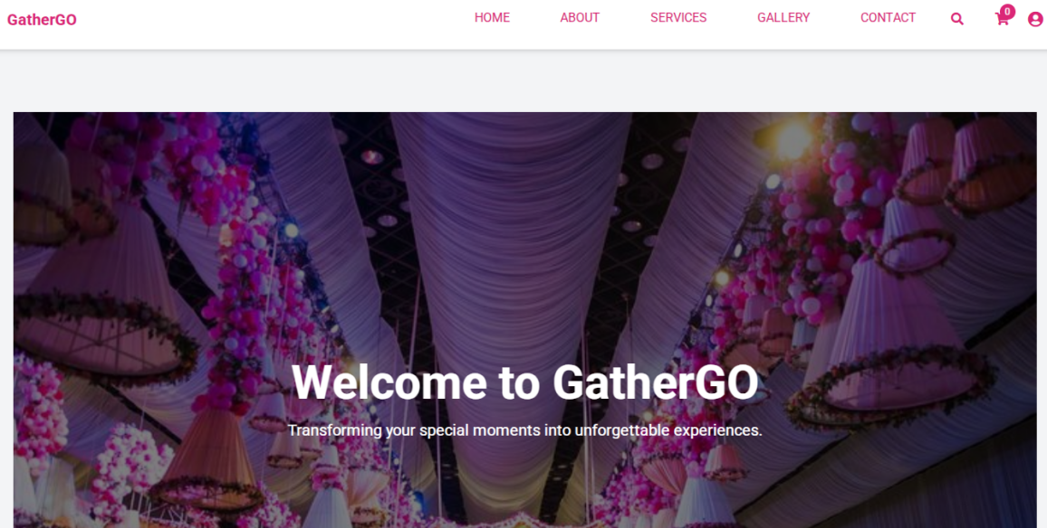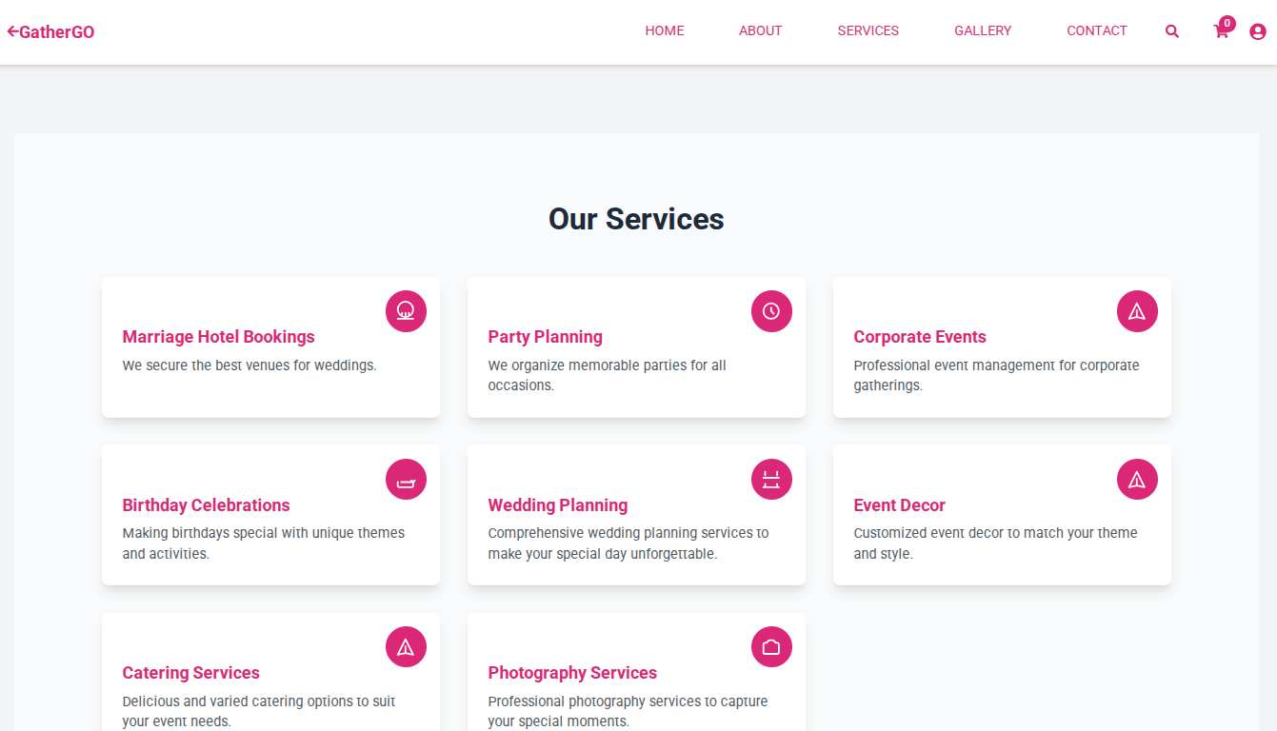

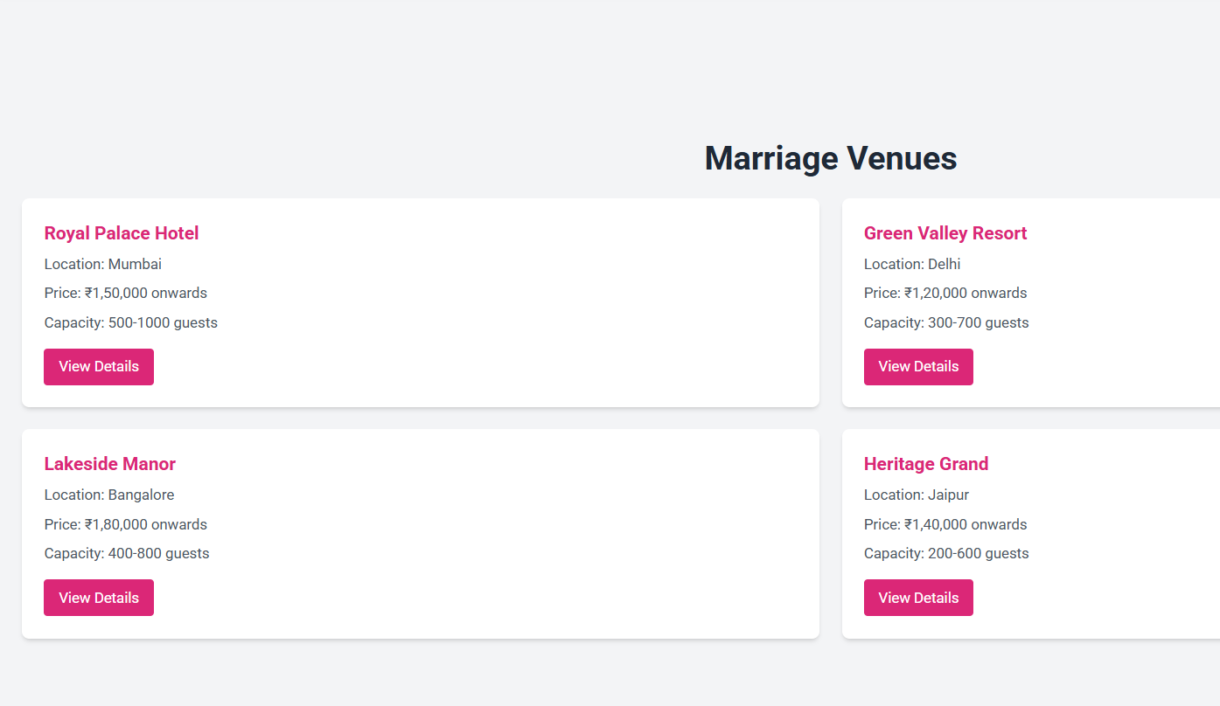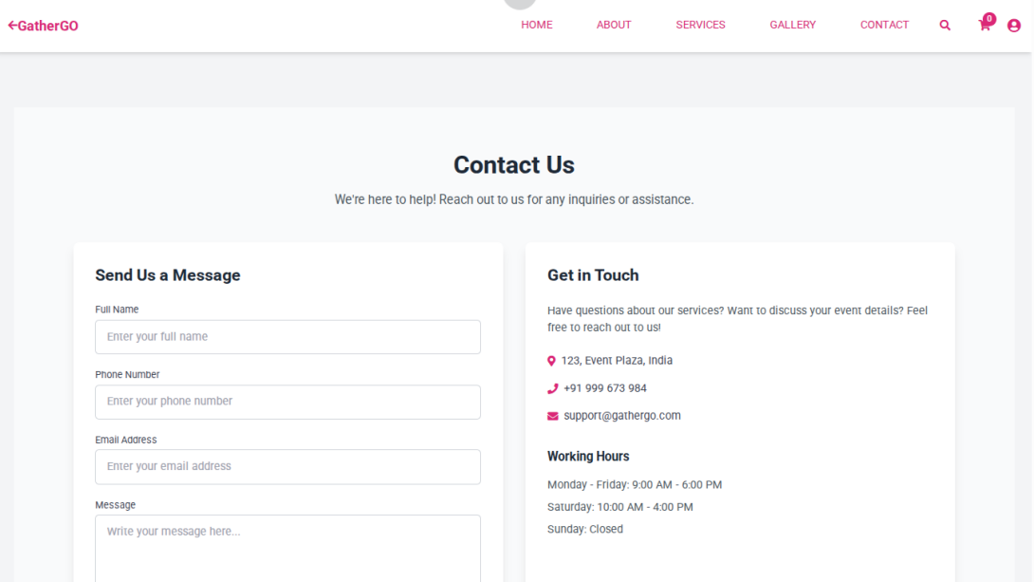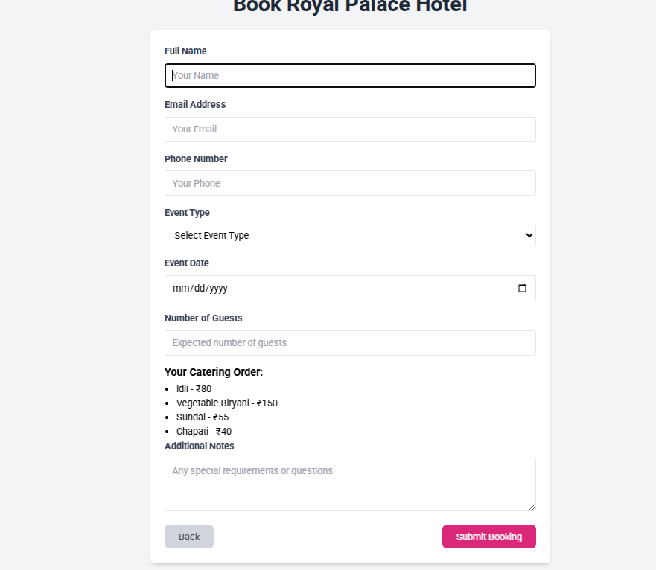

**6. CONCLUSION**

The Online Event Management System aims to revolutionize event planning by providing centralized platform that streamlines the management of events, vendors, guests, and payments. By automating and integrating various aspects of event planning, the system reduces human errors, improves coordination, and enhances the overall event experience for organizers and attendees alike

.**6.1 References**

1. **Book Title**: Web Development and Design Foundations with HTML5  
   Author: Terry Felke-Morris  
   Edition: 9th Edition
2. **Event Management Systems**: A Survey  
   Author(s): James R. Mason et al.
3. **CSS: The Missing Manual** – David Sawyer McFarlan

**6.2 Project Link**

https://github.com/lokya-1907/fieldProject/blob/main/FP%20B8.fp%5B1%5D.docx